# Assignment -4

Python Programming

| Assignment Date | 03 November 2022 |
| --- | --- |
| Student Name | Sam Rahul R |
| Student Roll Number | 732919ECR110 |
| Maximum Marks | 2 Marks |

# Question-1:

Write code and connections in wokwi for ultrasonic sensor.

Whenever distance is less than 100 cms send "alert" to ibm cloud and display in device recent events.

Upload document with wokwi share link and images of ibm cloud.

# Solution:

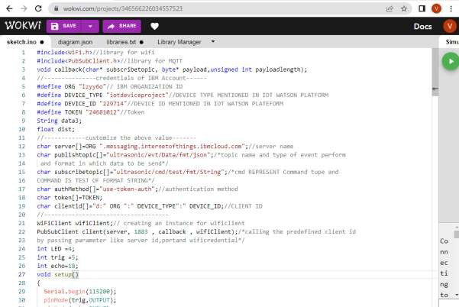

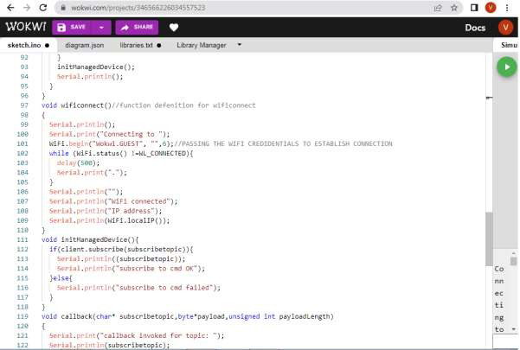

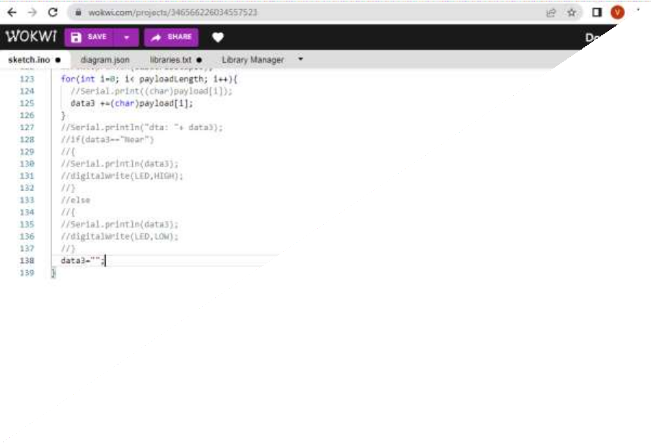

OUTPUT:

DATA IS SENT TO IBM CLOUD WHEN NO OBJECT IS DETECTED

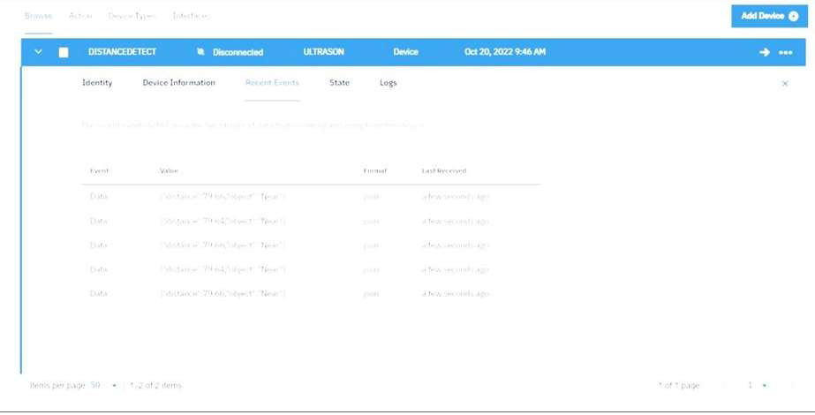

When no object is detected



When object is detected in ultrasonic detector

